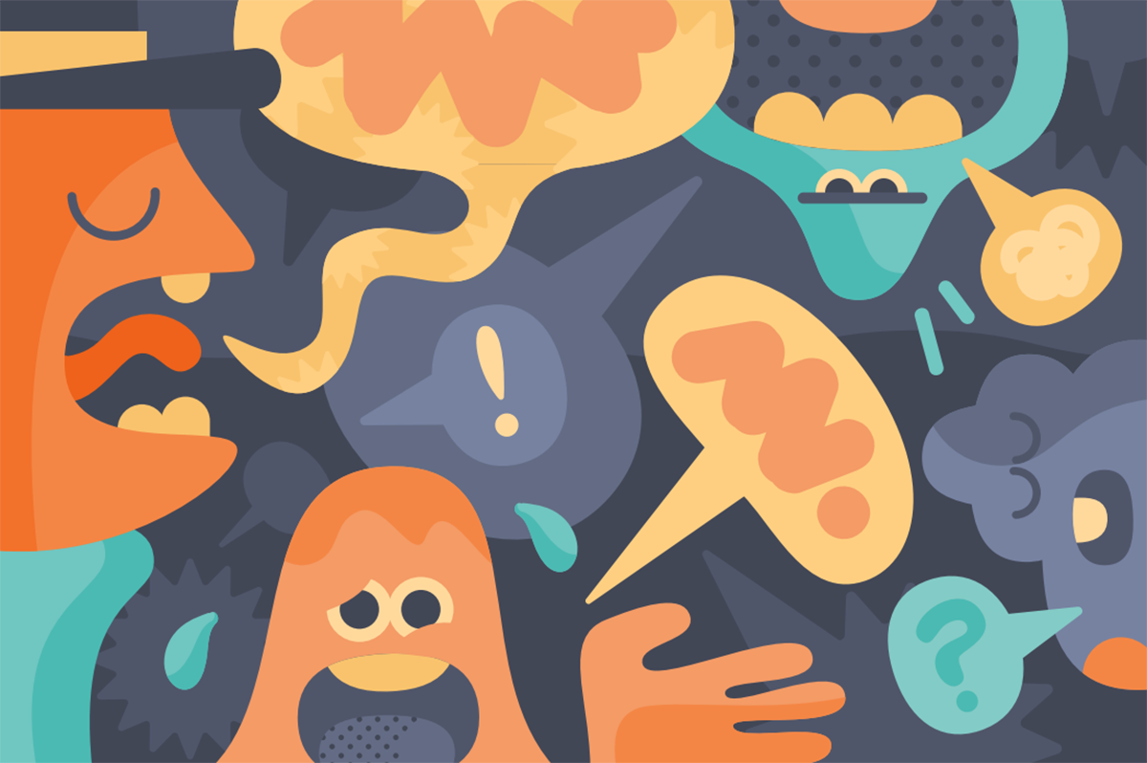
For NHS Employees
Stress Management
Course Workbook
Welcome
Welcome to this Stress Management course designed for NHS employees. We hope that you enjoy this course and that you find it helpful. This accompanying workbook will help you to work through the tools and techniques covered in this course. This course is based on Cognitive Behavioural Therapy (CBT) techniques, as well as Compassion Focused Therapy and Mindfulness.
What is CBT? It is a talking treatment that helps you think about:
- How you think about yourself, the World, and other people
- How what you do affects your thoughts and feelings.
CBT can help you to change how you think (“Cognitive”) and what you do (“Behaviour)”. These changes can help you to feel better. Unlike some of the other talking treatments, it focuses on the “here and now” problems and difficulties. It looks for ways to improve our state of mind now, rather than focusing on the causes of our distress or symptoms from the past.
How does it work?
CBT can help us to make sense of problems. It does this by breaking them down into smaller parts. It is then easier to see how they are connected and how they affect us.
These five key areas are:
- The Situation, relationships, and practical problems we face
- Our thoughts
- Feelings
- Physical symptoms
- And finally, our behaviour or activity levels
With CBT, the more you practice the tools and techniques, the more they will become second nature, and the more you will get out of them. This workbook will help you to practice what we will cover so that you can come back to it whenever you need.
Your CBT Cycle (come back to this page later)
Thoughts
What went through my mind at that time?
I think...
Physical Symptoms
What did I notice in my body? What did I feel? Where did I feel it?
I notice symptoms of...
Emotions
What emotion did I feel at that time?
How intense was that feeling? (0 – 100%)

Behaviours
What helped me cope and get through it?
What didn’t I do or what did I avoid doing?

Thoughts
Physical Symptoms
Behaviour
Emotions

Understanding Stress

The word ‘stress’ is usually used to describe the feelings we experience when the demands made on us are greater than our perceived ability to cope. At such times, we can often feel overloaded, under tremendous pressure and very tense or emotional. Stress affects everyone and is a completely normal reaction that all human beings will experience from time to time.

The stress container video:
LINK HERE

Common life events:

In our lives we experience many life events but sometimes these can get too much for us to manage and it can lead us to feel as though we cannot cope.
Some common life events that can contribute to our stress levels are:
- Neighbour problems | - Change of job
- Divorce/Separation | - Excessive working/ Work pressure
- Arguments at home | - Personal Injury or Illness
- Holiday / Christmas | - Financial worries
- Unemployment | - Retirement
- Moving House | - Pregnancy / Birth of a child
 | - Death of a family or friend
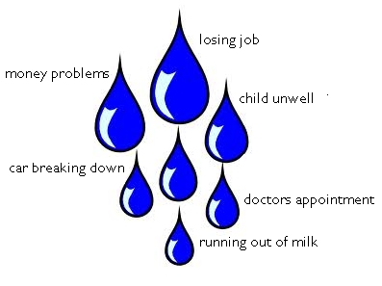
Make a list of factors that you feel are causing you stress currently:
.....................................................................
.....................................................................
.....................................................................
....................................................................
....................................................................
....................................................................

Understanding workplace stress within the NHS
- Do you think the NHS is a stressful place to work?
- What factors do you feel contribute to workplace stress working within the NHS? What are those things for you?
- High caseloads, understaffing, long hours (overtime), night shifts, emotional capacity, workplace/relationship dynamics, caring roles – the list can be long!
It’s important to recognise that within the NHS there can be many things that might contribute to increased stress. Lots of these things might be out of our control, and it is not down to our lack of “resilience” that makes things difficult. It is important to acknowledge how much you might actually deal with within your place of work, and how resilient you already are.
NHS staff are brilliant at coping and often have a strong belief that they should be able to cope with anything at all that comes along in their personal or professional domains. This belief can generate a superhuman philosophy that doesn’t make it easy to admit that we are experiencing stress. People who know you well at work or at home may be trying to tell you to slow down, to ‘take time out’, or you may be experiencing the ‘stop the world I want to get off ’ syndrome, but the temptation is to carry on regardless. There is some good news: showing signs of stress does not mean you cannot cope.
To admit to being stressed does not equal coping (although it can feel that way), quite the opposite, knowing and owning our limitations enables you to look for ways of coping more effectively so enhancing the range of coping mechanisms that you already have.
If you can take care of yourself the more effective you will be in your capacity to care for others.

HSE 6 Demands
https://www.hse.gov.uk/stress/standards/
The HSE 6 demands cover six key areas of work design that, if not properly managed, are associated with poor health, lower productivity and increased accident and sickness absence rates. The Management Standards are:
- Demands – this includes issues such as workload, work patterns and the work environment
- Control – how much say the person has in the way they do their work
- Support – this includes the encouragement, sponsorship and resources provided by the organisation, line management and colleagues
- Relationships – this includes promoting positive working to avoid conflict and dealing with unacceptable behaviour
- Role – whether people understand their role within the organisation and whether the organisation ensures that they do not have conflicting roles
- Change – how organisational change (large or small) is managed and communicated in the organisation

Take a moment to think about which areas you or your team are doing well in, and which areas might benefit from some changes. What are you already doing well? What else could you or your team do differently to help manage these areas?

------------------------------------------------------------------------------------------------------------------------------------------------------------------------------------------------------------------------------------------------------------------------------------------------------------------------------------------------------------------------------------------------------------------------------------
Week 1: How stress affects us physically

How stress affects us physically
What Physical Symptoms of Stress do I have?
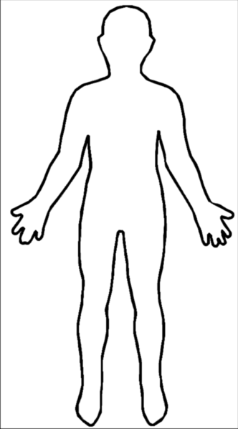

The Physical Symptoms of Stress and Anxiety
Body stops producing saliva = Dry mouth, Difficulty swallowing
Increased adrenalin makes vision sharper = visual disturbance (blurred vision)

Airways widen to let in more oxygen = Breathlessness, dizziness
Blood in skin is diverted to muscles = Pale skin

Heart pumps harder to send oxygen to the muscles = Heart racing, palpitations
Blood is diverted away from stomach to muscles = ‘knotted’ or ‘butterflies’ feeling in stomach, Nausea, Diarrhoea

Skin sweats to cool muscles = profuse sweating
Muscles in use, tense, ready to act faster = Tension, aches, and pains in muscles, ‘shaky’ feeling

The Fight or Flight response is the body's way of responding to being in danger. Adrenaline is rushed into our bloodstream to enable us to run away or fight.
This happens if the danger is real, or if we perceive the danger is real. It is the body's alarm and survival mechanism. Primitive man wouldn't have survived for long without this life-saving response; it is there to keep us alive. It works so well that it often kicks in when it's not needed, when the danger is in our heads. We think we're in danger, so that's enough to trigger the system!
When we’re stressed for a period of time, we can become hypervigilant - constantly on the lookout for danger, hyper-alert to any of the signals, this makes it more likely that the fight/ flight alarm system will be triggered.
Relaxation: 7/11 Breathing
Focusing on our breathing can be a really quick tool to help manage stressful situations. When we feel stressed, we tend to trigger the sympathetic nervous system response (the arousal, or ‘fight or flight’ response). By regulating our breathing, we can instead trigger the parasympathetic response (our body’s relaxation response). By breathing out slower than we breathe in, we can strengthen the relaxation response
The idea is simple:
- Breathe in for 7 counts…
- Breathe out for 11 counts…
- Repeat for a few minutes.

Recording of 7/11 breathing to practice at home:
LINK HERE

Week 2 & 3: How stress affects our thinking and managing Worry
- What changes in thinking patterns do you notice when you’re stressed?
- Do you worry more? Or ruminate?
- Or think of the worst-case scenario more often?

How Unhelpful Thoughts Affect Stress
If we look at the CBT cycle of stress, we can see that the way we think can impact our mood and our behaviour. When we feel stressed the way that we think changes. We may have unhelpful thoughts (i.e., “I’m useless”, “I can’t cope”) that can then maintain our stress.
Firstly, be more aware of your thoughts – keep a diary / write thought down.

Common Unhelpful Thinking Styles:
Adapted from www.getselfhelp.co.uk

All or Nothing thinking – Believing that something or someone can be only good or bad, right or wrong, rather than anything in between or ‘shades of grey’.  Things aren’t either totally white or totally black – there are shades of grey. Where is this on the spectrum?  Over Generalising – Applying the experience of one situation to ‘all the time’. Not getting one job becomes “I’ll never get a job”  Self-criticism – Putting ourselves down, blaming ourselves and taking personal responsibility for something that is not entirely our fault. “I must have done something wrong” “I’m stupid”.  Is this really my fault? Can I look at this another way?  Mind-Reading – Assuming we know what others are thinking (usually about us).  Am I assuming I know what others are thinking? What’s the evidence? Those are my own thoughts, not theirs. Is there another, more balanced way of looking at it?  Catastrophising – Imagining and believing that the worst possible thing will happen. OK, thinking that the worst possible thing will definitely happen isn’t really helpful right now. What’s most likely to happen?  Emotional Reasoning – “I feel bad so it must be bad!” “I feel anxious so I must be in danger”. Is this 100% true? | Filtering the positive – You only focus on the negative and disregard the positive.  Am I only noticing the bad stuff? Am I filtering out the positives? Am I soaking up the negatives and sieving out the positives?  Should, Ought’s and Musts – Thinking or saying, “I should” (or shouldn’t) and “I must” puts pressure on ourselves and sets up unrealistic expectations.  Am I putting more pressure on myself, setting up expectations of myself that are almost impossible? What would be more realistic?  Judgements – Making evaluations or judgements about events, ourselves, others, or the world, rather than describing what we actually see and have evidence for.  Is there another perspective?  Memories – Current situations and events can trigger upsetting memories, causing us distress right now.  Even though this memory makes me feel upset, it’s not actually happening again right now.  Prediction – Believing we know what’s going to happen in the future.  Am I thinking that I can predict the future? How likely is it that that might really happen?  Compare and Despair – Seeing only the good and positive aspects in others and comparing ourselves negatively against them.  Mountains and Molehills – Exaggerating the risk of danger / negatives. Minimising the positives.
Thought Challenges
Once you have recognised your unhelpful thinking habits, and once you have identified the thoughts that may be feeding into your cycle of stress (e.g., I’m a failure, the worst thing could happen), it can be helpful to ask yourself the following questions:

What is the worst thing...? What are the chances this will happen...?
- Often our minds are very good at thinking of the worst possible scenario in situations. How likely is it this will happen? And how bad would this be if it did happen?
- Often, we can overestimate the danger of a situation when we feel anxious and underestimate our ability to cope.

Am I right to think that...?
- What’s the factual evidence this thought is true? What assumptions are making me think this? My own opinions or past experiences?
- What about the other side of the coin, what tells you this thought might not be true?

Will this matter in five years’ time...?
- There are obviously stressful life events that do matter in the long term, but often many of our day-to-day stressful thoughts can feel really overwhelming at the time, but we often won’t feel the same way in even a week, a month, or 5 years’ time.
- We can react very emotionally in the moment, but asking yourself will it matter? Can help us to gain perspective.

What is this worth...?
- Is life too short to be worrying about something I can’t change?
- Is all this worrying worth it? For hypothetical worries the answer is often no.

What would I say to a friend in this situation?
- Would you give them words of encouragement to try something out and reassure them? - Or would you tell them they are being stupid and to get on with it?
- Often the things we say to ourselves we would never say to the people around us.

Next, try to come up with a more balanced / realistic thought.

Tip: It can also be helpful to actively try and focus on your positives / achievements each day. Even just thinking of 3 positive things from your day can help!
This could be 3 random things, or you could focus your positives on something you have:

Achieved
Connected with
Enjoyed
How often do we spend thinking about our achievements each day? Giving yourself a task to focus on this can help to balance our thoughts.

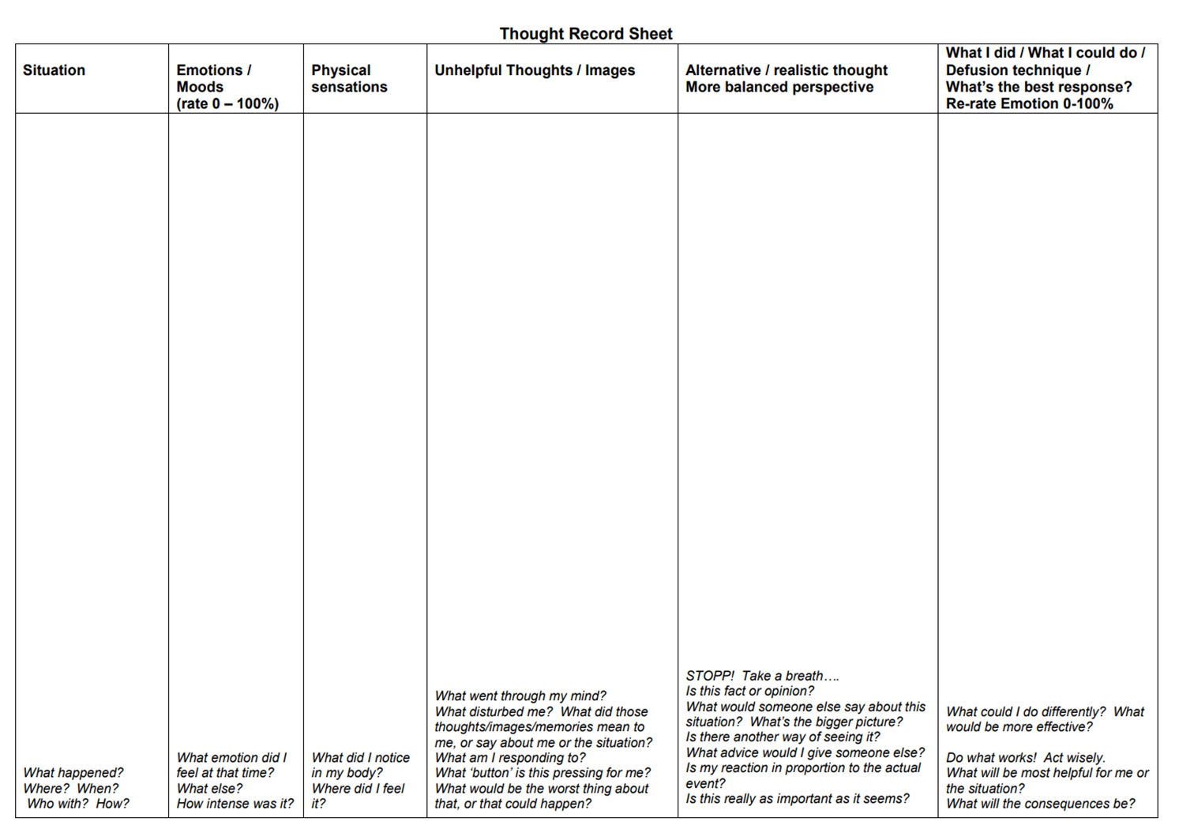

If we can’t do anything about our worry it is ‘hypothetical’ - something that may or may not happen! If we can do something about it is a ‘practical’ worry – something we can do something about. Making this distinction will help you manage your worries.

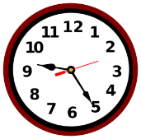
Worry time
This is a technique which some people find useful to help let go of hypothetical worries. You put aside around 15 minutes at a particular time of the day (e.g., / 8pm to 8.15pm. This is your ‘Worry Time’. If you start to worry about something at any other time throughout the day, tell yourself that you will save it for your ‘worry time’.
At worry time, sit down somewhere quiet and give yourself permission to worry about the things you have stored up over the course of the day. You may have forgotten some, some things may have already been resolved and you may find that you feel differently about some of the things you were worrying about now that some time has passed.
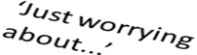
At the end of worry time try to re-focus your mind back onto the present. Maybe get up and go into a different room, or start doing something different, use all your senses to really tune in to what is going on around you. If you find yourself starting to worry again repeat the process: you will worry about it in your next worry time.
Worry Time Technique
Step One: Set a worry time. For example, 15 minutes at 7:30pm.
Step Two: When you notice a worry during the day, label it ‘I’m just worrying about....’, write it down if you can
Step Three: Accept the worry is there and ask yourself ‘Can I do anything about this right now?’ If no……
Step Four: Let the worry go (for now) and refocus attention using your senses
Step Five: At worry time, go through any worries you noticed during the day. Then repeat the process from step one.
Problem Solving
This can be helpful for solving those practical worries you may be experiencing.
How to Problem Solve
- Firstly, identify the problem. Be specific.

- Break it down into smaller steps and decide what you need to action first.

- Brainstorm and write down as many ideas as you can that might help solve the problem, no matter how silly they seem – don’t dismiss any possible solutions.

- Consider the pros and cons of each possible solution, using a separate piece of paper.

- Choose one of the possible solutions that looks likely to work, based on the advantages and disadvantages.

- Plan out step-by-step what you need to do to carry out this solution. What? When? How? With whom or what? What could cause problems? How can you get around those problems? Is this realistic and achievable?

- Do it! Carry out the plan.

- Review how it went. Was it helpful? Did you achieve what you set out to achieve? If not, how could you have done it differently? Did you achieve any progress, however small, towards your goal? What have you learned?

- If you achieved your goal – consider tackling the next step of your original problem.

- If you didn’t fully achieve your goal – adjust your chosen solution or return to steps 1 and 2 and choose another possible solution.

5 Steps to Problem Solving

1. Define & ‘reframe’ the problem.
Be specific – when or with what frequency does it occur, does it have a bigger impact depending on your mood, what impact do you feel it is having, what are the effects? Is it something we actually have any control over, or do we need to accept the situation & let go? Use the Worry tree to help make a decision.

Solution Works!

Solution doesn’t work

2. What are the options?
What are the options - Brainstorm all possible solutions – it helps to do this with a friend as they will bring a different perspective.

3. Make a decision.
Look at each solution & its consequence (pros & cons). Decide on the best option.

Solution does not work!
4. Try out the solution.
Monitor the result

5. Evaluation
Solution works: great!
Or Solution doesn’t work: review what went well & what didn’t go so well - return to step 1 or 2

Solution
works!
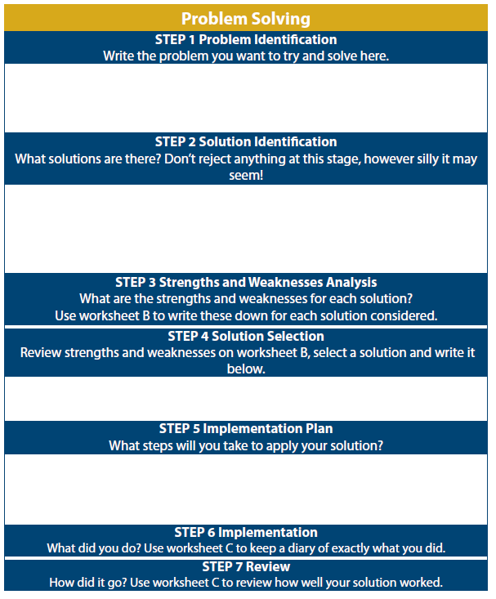
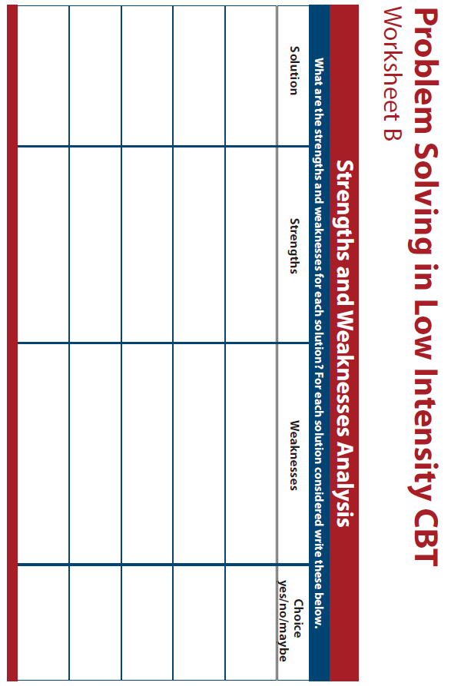
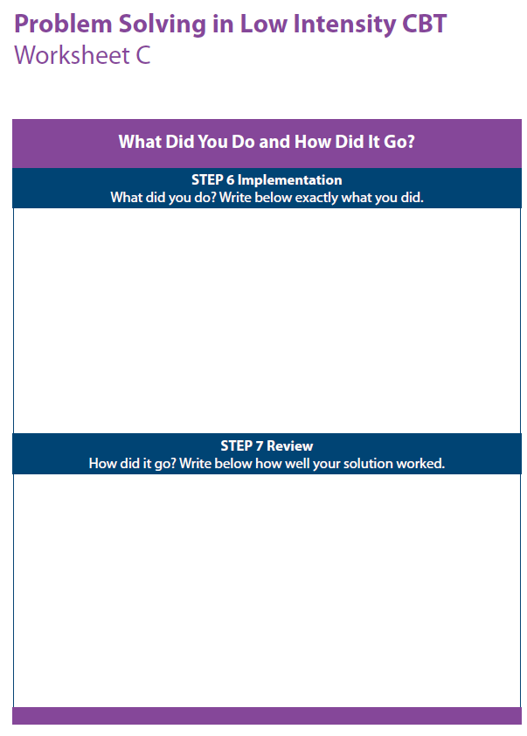

Circle of Control

What is outside of my control?

What is inside my control?

Attention Focus
When we worry it is often like we are living our life in the future, as our mind is caught up in all sorts of catastrophic scenarios of “what if” worries. This means that our body is in the present moment, but our mind is very much elsewhere. Often, we may not even be aware that our mind is doing this.
Worriers will often say that because of this, they miss out on what is happening in life here and now.
Training your attention though attention focusing exercises can be a useful way of bringing yourself out from the future with the worries back to the present moment. It will also help with worry time as we mentioned earlier – refocusing is key!
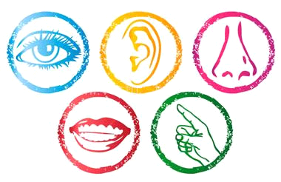
Below are some activities and exercises that can adjust our focus of attention:
5 senses
Using your 5 senses think about 5 things you can see around you, 4 things you can hear, 3 things you can touch, 2 things you can smell, and the last thing is to focus on your breath.
Mundane task focusing
Sometimes when we are doing everyday mundane tasks we are often on autopilot and do not focus on the task at hand. E.g. washing up, cleaning teeth, etc. We can use these tasks to practise strengthening our attention like a muscle.
The good thing about mundane task focusing is that you are not having to do anything extra in your day, it is just about changing how you pay attention to things you are already doing. Take a moment to think about the various... everyday routine tasks you do, that you could use as an opportunity to exercise your attention (e.g., doing the dishes, hanging washing, gardening, taking a shower, vacuuming, eating a meal, brushing teeth, walking, etc.
Mindfulness
Mindfulness means paying attention in a particular way: on purpose, in the present moment, and non-judgementally. This increases awareness, clarity, and acceptance of our present-moment reality. There are various apps or videos online that can help with practising Mindfulness. See the module work booklet for information.
Active exercise (e.g., cleaning, puzzles, colouring books)
Doing puzzles, crosswords, or other word games, reciting a poem, singing a song, or counting backwards from one hundred, are all useful distraction exercises. The important thing is that they take your attention away from the worrisome thoughts.
Progressive Muscle Relaxation (PMR)
PMR makes you focus on each muscle group one-by-one, therefore not on our worries in the future.

Week 4: How stress affects our behaviours
The Stress Hump
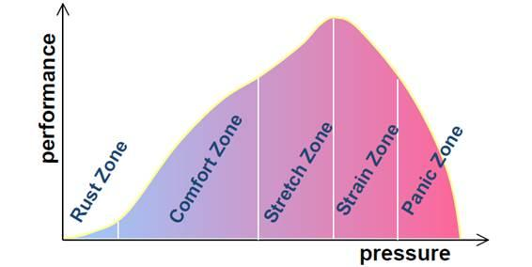
- Rust zone: we are doing very little; we have no challenge, drive, or motivation, for example someone out of work. (This is also the Depression Zone).
- Comfort zone: we are in a routine. We’re able to do all tasks and there are very few challenges - for example someone who has been in the same job for 10 years. They can do the job in their sleep and there is no challenge for them.
- Stretch zone/learning zone: this is where we function best – we are challenged but we can cope with the challenge. E.g., someone has just got a promotion they wanted – they are learning but coping.
- Strain zone: we are starting to feel like we can’t cope anymore – for example you started your promotion, but you underestimated how much work was involved and you are starting to feel overwhelmed. You can still function, but you are not at your best.
- Panic/burnout zone: you cannot cope at all anymore. It feels like you can’t do anything and can’t get going. You feel strong physical symptoms of stress.
Living in Line with our Values

- Our values are our compass in life, and when we feel separate from what is important to us, we can feel lost
- For example, if family time is important to us, but we don’t feel we have the time or opportunity to connect to our family, this can really impact our wellbeing
- Someone else’s values may be completely different to your own – that’s okay. It is what is important to you. Our values may also change over time.

Below you can find areas of life that are valued by some people. This questionnaire will help clarify your own quality of life in these areas.
Rate the importance of each area (by circling a number) on a scale of 1-10 (1 means that area is not important, 10 means that area is very important).
Not everyone will value all these areas, or value all areas the same. Rate each area according to your own personal sense of importance.

Values Exercise

Area | Not Important ------------------------------------------------ Very Important
Family | 1 2 3 4 5 6 7 8 9 10
Intimate Relationships | 1 2 3 4 5 6 7 8 9 10
Parenting | 1 2 3 4 5 6 7 8 9 10
Friends/Social Life | 1 2 3 4 5 6 7 8 9 10
Work | 1 2 3 4 5 6 7 8 9 10
Education/Training | 1 2 3 4 5 6 7 8 9 10
Recreation/Fun | 1 2 3 4 5 6 7 8 9 10
Spirituality | 1 2 3 4 5 6 7 8 9 10
Citizenship | 1 2 3 4 5 6 7 8 9 10
Health | 1 2 3 4 5 6 7 8 9 10
 | 1 2 3 4 5 6 7 8 9 10
 | 1 2 3 4 5 6 7 8 9 10
 | 1 2 3 4 5 6 7 8 9 10

Time, Effort and Head Space
Now, give a rating to how much time, effort, and head space you currently put into each area. In other words, how in line with your values are you? Are you living your life in accordance with your values?
1 = little time, effort and ‘head space’
10 = Maximum time, effort and ‘head space’
Area | Minimum ----------------------------------------------------------- Maximum
Family | 1 2 3 4 5 6 7 8 9 10
Intimate Relationships | 1 2 3 4 5 6 7 8 9 10
Parenting | 1 2 3 4 5 6 7 8 9 10
Friends/Social Life | 1 2 3 4 5 6 7 8 9 10
Work | 1 2 3 4 5 6 7 8 9 10
Education/Training | 1 2 3 4 5 6 7 8 9 10
Recreation/Fun | 1 2 3 4 5 6 7 8 9 10
Spirituality | 1 2 3 4 5 6 7 8 9 10
Citizenship | 1 2 3 4 5 6 7 8 9 10
Health | 1 2 3 4 5 6 7 8 9 10
 | 1 2 3 4 5 6 7 8 9 10
 | 1 2 3 4 5 6 7 8 9 10
 | 1 2 3 4 5 6 7 8 9 10

Value to step closer to ......................................................................
Goal......................................................................................................
Wheel of life exercise example
Have a go at creating your own wheel of life on a piece of paper. 0 is closer to the centre of the circle (which means you are less satisfied with this area), and 10 is at the outside edge of the circle (which means you are more satisfied with this area).
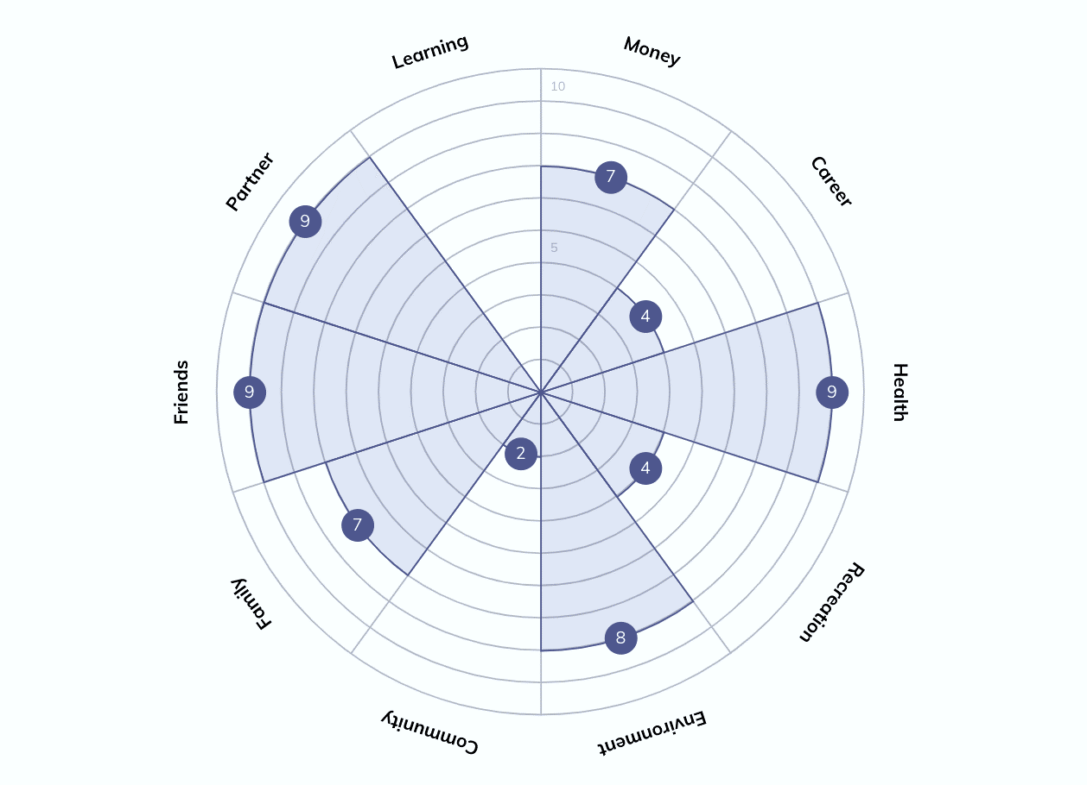

Overcoming Avoidance
- In the short term, facing up to the things which cause us stress may make us more stressed.
- In the long term, it will become easier if we keep facing up to these things.
- Doing these difficult things will increase our belief in our ability to cope “I can get through this”.
- As a result, our confidence will go up and our stress levels will come down.
- We can work on overcoming avoidance by breaking what we need to do down into really small, manageable chunks and rewarding ourselves when we have achieved this, even if it is just a little. Later in the workbook, we will discuss setting goals.
Behavioural Activation
- Behavioural Activation (or BA) is a CBT tool to help us regulate our routine and increase motivation.
- It can be helpful if we feel burnt out, unmotivated or low in mood, and helpful if we are doing too much to see how we can rebalance.
- When we feel burnt out or low in mood, we can put off doing activities that bring us joy, or those we need to do because we don’t feel like it. In the long run, this can make us feel worse. This is called the “reduced cycle of activity”
- Step 1 of this activity, if we are really feeling stuck or low, is to keep a “baseline diary”. This is where we keep a detailed diary for a week of all the things that we are doing. We do this so that we can reflect at the end of the week on whether there is a good balance across the week. We may notice at the end of the week that we spend a lot of time at work, or in front of the TV, and having these realisations may help us understand why we might feel like we do.

Morning | Monday | Tuesday | Wednesday | Thursday | Friday | Saturday | Sunday
Afternoon
Evening
How was I feeling today:
Mentally
Emotionally
Physically
Blank activity diary

Step 1 – Identifying Activities
Routine Activities  Day to day activities which make our lives more comfortable or routine habits | Necessary Activities  Essential tasks which have a negative consequence if we don’t do them e.g. bills | Pleasurable  Things that we enjoy that gives us a sense of value and connection
Brushing teeth | Paying bills | Seeing friends
Laundry | Food shopping | Gardening
Eating | Work | Reading
Regular bedtime | Taxing car | Watching a programme
Exercise | Booking GP appointment | Baking a cake
Cooking | Personal care | Learning a new skill
Walking the dog | Cleaning | Taking a bath

Identifying Activities
Make a list of the activities you think you’re avoiding or feel you’re not doing often enough or activities you used to enjoy but aren’t doing anymore
Routine Activities

Necessary Activities

Pleasurable Activities
Step 2 – Ranking Activities
Rank the activities you have identified in order of how difficult they would be for you to do right now. Tick whether they are routine, necessary, or pleasurable.
Easy Activities | Routine | Necessary | Pleasurable

Moderate Activities | Routine | Necessary | Pleasurable

Difficult Activities | Routine | Necessary | Pleasurable

Step 3 – Planning Activities
Next, chose a variety of routine, necessary, and pleasurable activities to plan into your week. Start with the easiest activities first to set yourself up for success.
Tips for Successful Plans:
- Make small steps.
- Make sure your plan is realistic and achievable
- Maintain a balance of routine, necessary, and pleasurable activities
- Once it is in your diary, no matter how you feel, do it! You will feel better after.
It’s quite normal for this to feel difficult at first. You may find you don’t enjoy the activities that you used to. The more you stick to your plan, the more that enjoyment will return, and you will see your motivation increase.

Obstacles and Solutions
Starting the activity is too difficult | Try the activity for just five minutes
Tasks are too large | Break them down into smaller tasks
Energy and motivation are lacking | Set specific times in your planner for activities  Bargain with yourself; if I do x minutes of this, then I can watch TV afterwards
I don’t have enough time | Focus on having a balance of activities rather than increasing how much you’re doing
I don’t feel better yet | Complete the activities in spite of how you feel and over time you will see a change
Week 5: Burnout and overdoing it
If you find your problem is having too much on or not having enough time, you can use your BA diary to pace your activities and focus on getting a balance between the three activities types rather than increasing how much you are doing.
Burnout
Signs we are overdoing it
- Eating and working (no lunch break)
- Forgetting things
- Talking on phone whilst cooking
- All at once: TV, Facebook, talking, working,
- Rushing everywhere
- Talking too fast
- Feeling tired and burnt out
- Experiencing “compassion fatigue”
When we are doing too much
- If we feel like we have too many things to do and not enough time, we can easily feel stressed and overwhelmed. Often jobs can pile up and it can feel like we have a mountain to climb.
- Turn your mountains into molehills. Break down one big task into as many smaller tasks as possible.
- Put these smaller tasks into order of importance, and deal with the most important one first. Do not move onto the next task until the first one is finished.
- Keep an up-to-date list of what you need to do. Get in the habit of crossing each thing off as soon as you do it. You might dedicate 10 minutes before dinner each night to update your list and make a plan for when you are going to do these things.
- Don’t put too many things on the list to start off with; this can make you feel disheartened about how much you must do. Thinking about what you might be able to achieve in a chunk of time e.g., a morning, can be helpful.
- Don’t forget to timetable in things you enjoy, not just jobs you have to do!

Urgent/Important Task Matrix
The urgent/important task matrix can be a helpful tool to use when we feel like our to-do list is never-ending. What is urgent, and needs to be done today? Are there things on there that can wait? Can I enlist the help of anyone else for anything on my list? Can I drop things that really don’t need to be done right now?

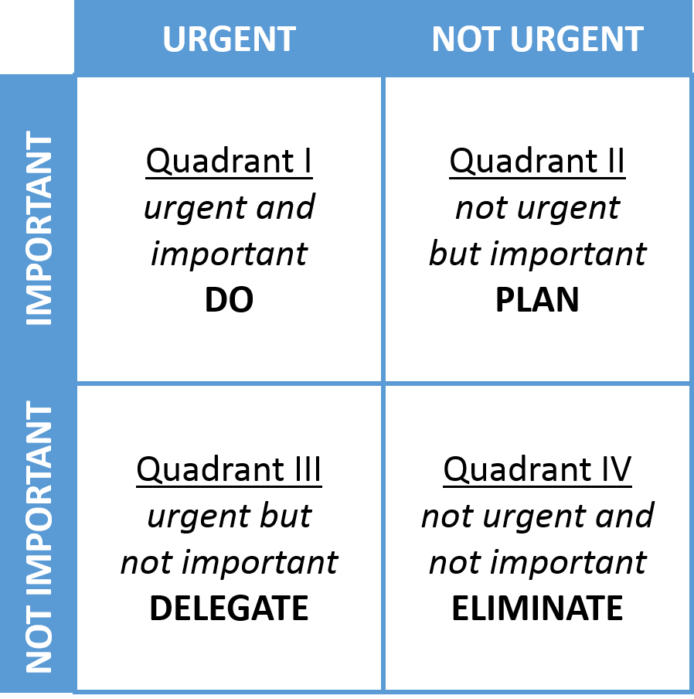

Symptoms of burnout:
You might be approaching burn out when you:
- Have reached exhaustion and can no longer motivate yourself
- Feel depressed, unhappy, or even suicidal
- Feel increasingly cynical and negative
- Experience “compassion fatigue”
- Feel helpless, detached, or trapped
- Experience decreased satisfaction and a sense of accomplishment
- Experience prolonged physical symptoms (e.g., headaches, feeling run down)
- Feel that the pressures seem so overwhelming that your performance, mood, and health are suffering significantly
- Are unable to maintain the level of health you need to carry out your professional role
Burnout recovery:
- Take your foot off the accelerator – it is okay to stop & slow down
- Recovery from burnout is often not an overnight process
- Remember that feeling stressed or burnt out is not a failure
- Turn compassion towards yourself
- Communicate with your manager & team
- Remember that your employer carries a responsibility for your health and safety at work, which includes your emotional/mental health as well as your physical wellbeing
- Seek support & help
- Remember “good enough” is good enough! Some people that suffer from burnout can struggle with perfectionism and give themselves a hard time if their work is not always at a high standard, even if it is at detriment to themselves.
- Check out the recorded “Burnout Conversations” here:
Burnout Session Recordings - People Portal (hiowpeople.nhs.uk)
Box breathing technique
- Before box breathing, sit in a chair or lie down on your back with one hand on your chest and one hand on your stomach. When you sit on a chair, make sure that your back is straight and supported and your feet are placed on the floor.
- Breathe as you would normally for 1 minute before box breathing, observing the rise and fall of your chest and stomach.
- Focus on bringing the breath down into the belly, so that your breath is deep, and not just shallow in the chest. This will help your body and mind to relax.
- Step 1: Breathe in counting to four slowly in your mind, feeling the air enter your lungs as you inhale.
- Step 2: Hold your breath at the top of the inhale for 4 seconds.
- Step 3: Slowly exhale through your mouth for 4 seconds.
- Step 4: Repeat steps 1 to 3 for as long as you like until you feel re-centred. Even 1-3 minutes of this practice can make a big difference in how we feel.

Week 6: 4 Pillars, 5 Ways to Well-Being, Goal setting & Communication

The Four Pillars
While there might be lots of reasons for changes in our mental health, but often our self-care can be forgotten when we feel down, stressed, or anxious. Our wellbeing is supported by these 4 areas, like 4 pillars supporting a building. If one or two of them are being neglected, they become wobbly and this can make the building become unstable. Evidence suggests that these four areas can provide us with a solid foundation to start making changes which might help us feel better.
The Four Pillars
Sleep
Physical
Activity
Nutrition

Relaxation

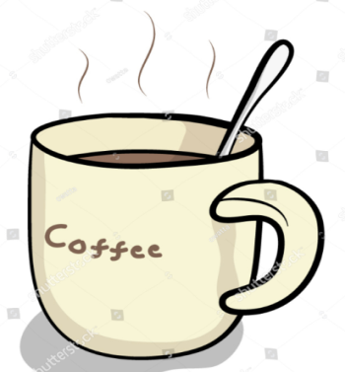
Diet
Healthy Eating
Eating healthily is not only good for us physically; it can be just as important for our mental health. Eating a balanced diet including slow-release energy
foods can be beneficial for regulating our energy levels and mood. It’s also recommended to eat at regular times throughout the day. High sugar
foods (ready meals, cereal bars, snacks) can cause spikes in our
mood and maintain stress levels.
Caffeine
Caffeine is a stimulant; it can increase the heart rate and brain
activity. Excessive amounts can create a ‘high’ feeling;
however when caffeine leaves the body a ‘low’ feeling can
quickly follow. Excessive amounts can cause physical
symptoms similar to anxiety. Drinking caffeine can also cause
sleep disturbance. Aim to limit to no more than 2-3x coffees per
day and try to cut out caffeine after midday.
Alcohol
When we are stressed, in the short-term alcohol appears to relieve symptoms of stress, but in the long-term, prolonged, and excessive use of alcohol can lead to a whole host of problems. Alcohol is a depressant but when processing alcohol in the days after drinking our body simulates the symptoms of anxiety – so it can also actually increase both feelings of depression and anxiety. Alcohol has a depressant effect and can lead to deterioration in mood and can also interfere with sleep patterns. It can be used by some to help ‘numb’ emotions, to help people avoid confronting difficult issues.
Tip: We’re not suggesting that you can never drink alcohol or caffeine. It is important, however, to consider whether your alcohol or caffeine intake is a factor that could be maintaining your stress levels.
Sometimes people find that if they are going through a stressful period, it can be helpful to reduce or eliminate alcohol or caffeine, to try and help reduce some of the physical symptoms. Find the balance that works best for you!
Exercise
Physical Activity - It has long been known that regular exercise is good for our physical health; however, it can also be very good for our mental health. It can improve mood, reduce anxiety, and improve concentration. Exercise influences certain chemicals in the brain (e.g., serotonin), that affect our mood and can make us feel happier. It can also improve energy levels and helps to regulate and improve sleep. The current guidelines are 150 minutes a week of moderate activity – this includes fast walking, housework, dancing, or gardening.
Most importantly, it’s about finding the type of physical activity that works for you, even breaking activity down into small bursts of exercise spread across the day. This may also mean building activity gradually and planning a time that fits in with your life. Check in with the SMART goal section later on in the booklet to help set yourself achievable exercise goals.
Exercise Ideas

Exercise Plan:
Monday | Tuesday | Wednesday | Thursday | Friday | Saturday | Sunday

Sleep:
10 Rules for a good sleep routine
- Limit caffeinated products
- Avoid nicotine
- Avoid alcohol around bedtime
- Avoid heavy meals just before bedtime
- Keep bedroom tidy, calm, and ensure mattress and bedding are comfortable
- Avoid HI exercise 2 hrs before bedtime if possible
- Control extremities in temperature
- Keep bedroom quiet and darkened
- Keep your bedroom mainly for sleeping avoiding watching TV, working, using the computer, or eating
- Keep awake & get up time, constant always and avoid napping during the day

Create the right atmosphere and routine
We need to create our own routine in the evening that tells our mind and body to wind down to prepare for sleep. In addition, we need to consider what we do during the day, and the bedroom environment itself – to give ourselves the best chance of sleeping.
- Moderate (not vigorous) exercise is great in the day to make us tired – but not in the four to six hours before bed. Gentle exercise such as stretching or gentle walking is excellent before bed.
- Finish any caffeinated drinks four to six hours before bed and avoid alcohol before bed.
- Don’t eat too close to bedtime and avoid spicy or very sugary foods as this can keep you awake during the night.
- Smoking (nicotine) will wake you up rather than calm you down.
- If you like a bath to relax, have it an hour or so before bed, so the body is then cooling down, which promotes sleep.
- Establish a routine with a regular bedtime and regular waking time.
- Try not to nap in the day/evening
- Keep a notebook by the bed to record anxious thoughts, worries or “things to do” that pay pop into your head

Make a note of anything you think could improve your sleep:
................................................................................................................................................................................................................................................................................. ......... ......... ......... .................

Still having problems? Try associating bed with sleep
The more we are in bed awake, worrying, perhaps tossing, and turning, watching TV, reading or using a computer, the harder it is to sleep. We start to associate bed with stress and being awake, instead of sleep.
- Don’t try to sleep until you feel sleepy (whatever the clock says) – stay up until you really feel you cannot stay awake another moment. If you are not asleep after 15-20 minutes of putting out the light, or you wake in the night and are still awake after 15-20 minutes then get up, go into another room, and do something relaxing or boring until you are sleepy again. N.B. – you’ll need to check the clock the first few times, but in general it’s not helpful to keep checking the time if you are lying awake Prepare for this – decide what you will do, and where you will do it. Have a warm blanket and maybe a relaxing CD ready in the room you will use, fill the kettle, and find a non-caffeine drink for when you need it. Keep the light level low.

- The bedroom should be quiet, cool, and dark (light is a signal to us to wake up), and free of TVs, computers and so on. If you are sharing with a partner, you may need to consider earplugs or negotiating over the weight of the duvet!

- Make your bed as comfortable and supportive as you can; mattresses can be expensive to replace, so if yours is old you could try putting a cheap duvet under the bottom sheet. Are you doing enough to use up your energy resources?

Relaxation
Why is relaxation helpful?
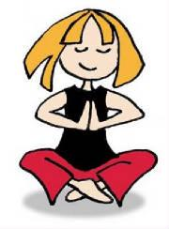
- When we are stressed the muscles in our bodies tense up and this muscular tension causes uncomfortable feelings such as headache, backache, tight chest and so on.
- These aches and pains of tension can cause us to worry about why we have aches and pains, and therefore make us even more anxious and tense. People who are tense often feel tired.
- Relaxing slows down the systems in the body that usually speed up when we get anxious. If we can learn to turn on the bodily symptoms of relaxation, we can turn off the symptoms of tension. Both systems cannot run at the same time.
- Stress affects our thoughts and our perceptions of our self, others, and the world around us. By focusing on relaxation, we can reduce some of the physical symptoms of stress and allow ourselves to take a step back and think differently about things.
Relaxation as a skill
- The ability to relax is not always something that comes naturally; it is a skill which must be learnt. This takes time and practice. The more we practice, the easier it becomes and the better the results. Daily practice is recommended.
- There are different methods of relaxation (including breathing techniques, progressive muscle relaxation, visualisation), there is evidence that relaxation is effective but nothing to suggest that one method is better than another. Find the one that works best for you!
- Try and be patient when practicing and try not to get too frustrated if your mind wanders. The more we notice out mind drifting, the more we can be mindful and bring our attention back to the practice.

Goal setting
How do I make it easier to achieve a goal?
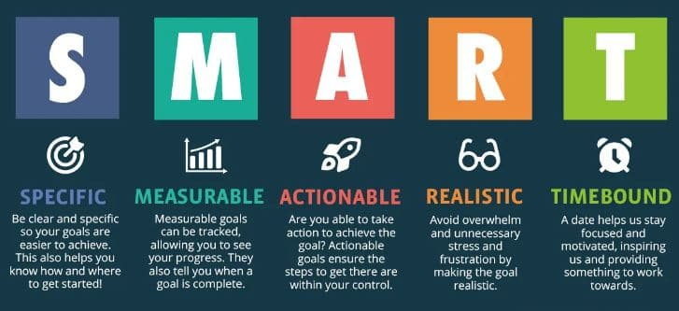
To help set appropriate goals, look at the following 5 aspects in SMART goals:

- Specific … - Do you know exactly what the goal is?
- Measurable……… - How will you know when you get there?
- Actionable……… - Can the task actually be carried out?
- Realistic…… - Is this a realistic goal?
- Time-bound …… - When will you get there?
Examples
Poor goal: “I want to walk more”.

SMART goal: “I would like to be able to go for a walk for 20 minutes at least 3 times a week”.
Five Steps to Wellbeing
Connect
Having good relationships with other people is important for wellbeing. That doesn’t mean you have to be out or entertaining every night – you may have just one or two people you feel close to (‘strong’ connections), or you may be happy spending time with others sharing a hobby – or just being in other people’s company without saying very much (‘broad’ connections). Think of all the people that you may come into contact with over a week – neighbours, postal staff, the lady in the corner shop or post office, your child’s teacher…how could you connect more with them?
Be Active
(The less we do, the less we want to do…)
Physical activity makes the body produce various chemicals which boost mood; these include endorphins (the body’s natural ‘happy hormones’, also serotonin (which anti-depressants also increase) and enkephalins, which are natural pain killers. It also relieves tension and calms anxiety, and can be a helpful distraction from worries, as well as helping you to feel in control of your health. Just 20 minutes per week of any physical activity is enough to start to lift mood (even better if its outdoors!), ideally moving up to 30 minutes five times per week (MIND Guide to Physical Activity 2006) , kept up for three months (NICE guidelines 2004).
Take Notice
What happens when we feel low, or are worried about something? We tend to focus inwards – towards our problems, or painful past experiences, or what may go wrong in the future. We may spend a lot of time trying to puzzle out where we have gone wrong (because we probably feel we have gone wrong somewhere – and if we could only work out where, we could put it right…) Sound familiar?
We need to take a break from all this – by switching focus to what is happening outside ourselves, right now. When you are out walking, take time to notice what is around you, to really see the trees, or the cars, or the houses you pass. If you find yourself sitting worrying but getting nowhere, distract yourself for a time by picking up the paper and doing the crossword, or looking at what is going on in your local area. When you are being active or connecting with others – really focus on that experience. The more you notice, the more you start to know what you like, and what is important to you. Then you can do more of it!
Keep Learning
Learn a new skill (or revive an old one), do something different, change your routine, try a new pattern or recipe, use a new tool… Set a goal and achieve it. Deciding what you want to do differently and setting yourself an achievable challenge will boost your confidence. You don’t have to be good at something to benefit from doing it!
Give
“Helping, sharing, giving and team-oriented behaviours are likely to be associated with an increased sense of self-worth and positive feelings.” (Foresight Mental Capital and Wellbeing Project 2008)
You may feel that you have little to give – perhaps your health condition has prevented you from doing those things for others that you used to do, or you were used to giving through donating or through doing your job, and you can no longer do this. Can you give time, your knowledge, or skills? Can you smile at the next person you see out walking your dog, or pass a friendly comment to the young person on the till in the shop? Can you let the person in a hurry go in front of you in the queue? An act of kindness will help your own wellbeing as well as help others.

Think of examples of how you could use the 5 ways to well-being below:
Connect | Be Active | Take notice | Keep learning | Give

Leaves on a stream meditation
- Sit in a comfortable position and either close your eyes or rest them gently on a fixed spot in the room.
- Visualize yourself sitting beside a gently flowing stream with leaves floating along the surface of the water.
- For the next few minutes, take each thought that enters your mind and place it on a leaf… let it float by. Do this with each thought – pleasurable, painful, or neutral. Even if you have joyous or enthusiastic thoughts, place them on a leaf and let them float by.
- If your thoughts momentarily stop, continue to watch the stream. Sooner or later, your thoughts will start up again.
- Allow the stream to flow at its own pace. Don’t try to speed it up and rush your thoughts along. You’re not trying to rush the leaves along or lose sight of them. You are allowing them to come and go at their own pace.
- If your mind says, “This is silly,” “I’m bored,” or “this can’t be right” place those thoughts on leaves, too, and let them pass.
- If a leaf gets stuck, allow it to hang around until it’s ready to float by. If the thought comes up again, watch it float by another time.
- If a difficult or painful feeling arises, simply acknowledge it. Say to yourself, “I notice myself having a feeling of boredom/impatience/frustration.” Place those thoughts on leaves and allow them float along.
- From time to time, your thoughts may hook you and distract you from being fully present in this exercise. This is normal. As soon as you realize that you have become side-tracked, gently bring your attention back to the visualization exercise.

If you would like to practice this meditation in a guided way follow the YouTube -
LINK HERE

Week 7: Moving Forward, Relapse Prevention
Relapse Prevention
My Early Warning Signs of Stress
Make some notes of the symptoms that you experience first when you get stressed. Keeping an eye out for these will help you to recognise when stress levels are creeping up. It’s normal for stress to go up and down as situations and events around us continue to change day to day but knowing what our warning signs are can really help us stay on top of things.
Relapse Prevention Planning

It is often helpful to set aside a regular time to refresh your memory of what we covered here and to renew your determination to make and maintain behavioural changes.

By identifying a specific time when it would be helpful for you to do this, you are more likely to remember to do this.

Write down when, where and for how long you will have your “check in” with yourself:

_______________________________________________________________

How many weeks do you think it would be helpful to continue to “check in”? _____

Decide what you will do during your check-in.

Some suggestions are below:
- Am I still doing the “everyday” things I need to do to manage my stress levels?
- Am I living in accordance with my values?
- Am I experiencing a particularly challenging time at the moment? Do I notice any warning signs? If so, what would it be helpful to do in response?
____________________________________________________________________________________________________________________________________________________________________________________________________________________________________________________________________________________________

Relapse Prevention Reflection Questions
Maintaining Change
What tools have you found useful?

How will you prevent relapse in the future?
My Relapse Prevention Planner
What have I learned?

What was most useful?

What can I continue to do to prevent a relapse?

What are my high-risk situations of this happening?

What are the signs? …

What can I do to avoid losing control?

When I’m struggling or feeling bad, what could I do that will help?

What could I do if I did lose control?
What has helped? What have I learned? Who can help?

In case of a setback… How can I make sense of this?

What events / triggers led up to this setback? How did I react to this? What did I do? What did I think? What did I feel?

What have I learnt from it?

Was this a high-risk situation? Are there things that I can identify are difficult?

What helped and what didn’t?

With hindsight, what would I do differently?

When I think / feel………………………………what could I do instead?

Seeking Support
If you feel that you are not able to cope with the demands of work or are not able to balance work and home life, then please do seek support. It is important that your line manager knows that you are struggling, so that things can be put into place to support your wellbeing. Ensure you:
- Have regular 1-2-1s in your diary
- That time (1 hour) is protected for your 1-2-1s between you and your manager
- Request catch ups between your 1-2-1 meetings if necessary.
- Use your 1-2-1 template to ensure you are having effective conversations that prioritise your needs and health and wellbeing.
- Self-refer into the Occupational Health and Wellbeing team if you would like further support with work life balance or other areas.
- Ask your manager to complete a manager’s referral so that you can discuss any reasonable adjustments or other concerns with an Occupational Health Advisor.

Additional Resources
Self-compassion meditation
- People Portal
- Anxiety UK: Self-help leaflets available for downloading
- Mental Health Foundation
- Reading Well and Books on Prescription
- Age UK - information and advice for older adults
- It’s good to talk - Find local private counsellors and therapists who are accredited
- Cruse- advice and counselling for bereavement
- Relate - specialists in relationship counselling for individuals, couples and families
- Solent Mind
CBT Information
- Centre for Clinical Interventions: Free workbooks
- Get Self Help: CBT self-help resources
- Northumberland self-help resources

Apps
- ReachOut by WorryTime
- WoeBot
- Unmind
- Clarity
- Sleepio

Meditation & Sleep
- Headspace (currently free for NHS staff)
- Calm (paid)
- Insight Timer (free)
- Calm sleep stories – Stephen Fry’s Blue Gold (free)
- Yoga Nidra for Sleep (free)

